HR ANALYTICS DASHBOARD

* -- total count of EMPLOYEES
* select count("Employee Count") as total_employees from hrdata
* -- where education ="high school"
* -- where department = "sales";
* -- where department = 'R&D';
* 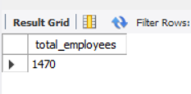
* -- Attrition count
* select COUNT(ATTRITION) as Arttrition_count FROM HRDATA
* WHERE ATTRITION = 'YES'
* -- and education = 'doctoral degree';
* -- and department = 'R&D';
* -- and education ="high school" ;
* 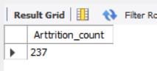
* -- Attrition Rate
* SELECT
* ( (SELECT SUM(`Employee Count`) FROM HRDATA WHERE Attrition = 'Yes' ) * 100.0
* / (SELECT SUM(`Employee Count`) FROM HRDATA) ) AS Attrition_Rate
* -- Active Employees
* SELECT
* ( (SELECT SUM(`Employee Count`) FROM HRDATA)
* -
* (SELECT SUM(`Employee Count`) FROM HRDATA WHERE Attrition = 'Yes')
* ) AS Active_Employees;
* 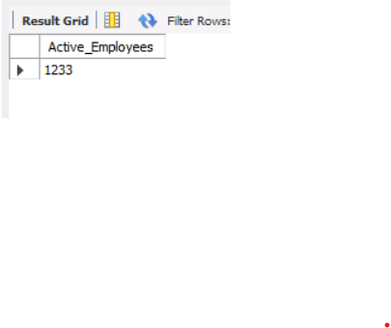
* -- from Gender wise
* SELECT
* ( (SELECT SUM(`Employee Count`) FROM HRDATA WHERE Gender = 'Male')
* -
* (SELECT SUM(`Employee Count`) FROM HRDATA WHERE Attrition = 'Yes' AND Gender = 'Male')
* ) AS Active_Employees_Male;
* 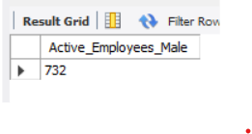
* -- AVG AGE
* select round (avg(age),0) as Avg_Age from hrdata;
* 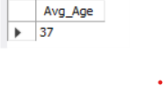
* -- Attrition by Gender
* select Gender , count(attrition) AS Attrition_Count from hrdata
* where attrition = "yes"
* group by Gender
* order by Attrition_Count asc ;
* 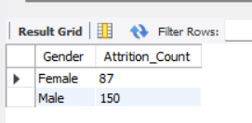
* -- Department wise Attrition
* select Department, count(attrition) as Department_Attrition from hrdata
* where Attrition = "yes"
* group by Department
* order by Department_Attrition asc;
* 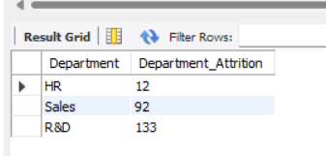
* -- % WISE Attrition
* SELECT
* Department,
* COUNT(Attrition) AS Department_Attrition,
* (COUNT(Attrition) * 100) /
* (SELECT COUNT(Attrition) FROM HRDATA WHERE Attrition = 'Yes') AS Attrition_Percentage
* FROM HRDATA
* WHERE Attrition = 'Yes'
* GROUP BY Department
* ORDER BY Attrition_Percentage ASC;
* 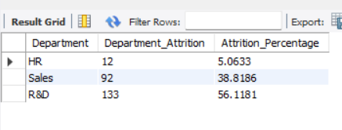
* -- No of Employees by Age Group
* SELECT Age, COUNT(*) AS No_of_Employees
* FROM HRDATA
* GROUP BY Age
* ORDER BY Age ASC;
* 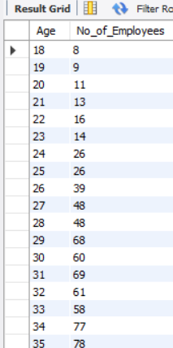
* -- Education Field wise Attrition
* SELECT
* `Education Field`,
* COUNT(Attrition) AS Education_Attrition
* FROM HRDATA
* WHERE Attrition = 'Yes'
* GROUP BY `Education Field`
* ORDER BY Education_Attrition DESC;
* 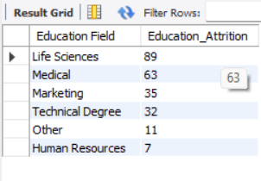
* -- Attrition Rate by Gender for Different Age
* SELECT
* age,gender,
* COUNT(Attrition) AS age_gender_Attrition
* FROM HRDATA
* WHERE Attrition = 'Yes'
* GROUP BY age,gender
* ORDER BY age_gender_Attrition DESC;
* 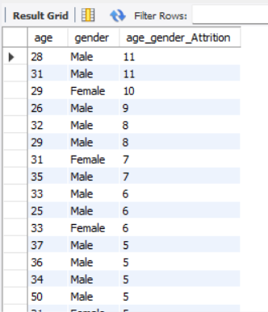
* -- JOb Satisfaction Rating
* SELECT
* `Job Role`,
* SUM(CASE WHEN `Job satisfaction` = 1 THEN 1 ELSE 0 END) AS Rating_1,
* SUM(CASE WHEN `Job satisfaction` = 2 THEN 1 ELSE 0 END) AS Rating_2,
* SUM(CASE WHEN `Job satisfaction` = 3 THEN 1 ELSE 0 END) AS Rating_3,
* SUM(CASE WHEN `Job satisfaction` = 4 THEN 1 ELSE 0 END) AS Rating_4
* FROM HRDATA
* GROUP BY `Job Role`
* ORDER BY `Job Role`
* LIMIT 0, 10000;
* 